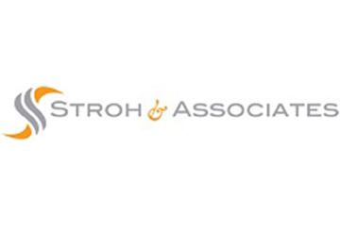
IRS Issues Guidance on COVID-19 Relief for Health FSAs and DCAPs
Highlights
Affected Plans
The new guidance affects Section 125 plans, health and dependent care FSAs, and HRAs.
Plan Amendments
Employers can amend their plans retroactively to the beginning of the applicable plan year, so long as the plan operates in accordance with the amendment terms for the relevant period and employees are informed of the change.

On Feb. 18, 2021, the IRS released Notice 2021-15 to clarify special rules for Section 125 plans, health flexible spending arrangements (FSAs) and dependent care assistance programs (DCAPs).
Temporary Special Rules for Health FSAs and DCAPs
The Notice is intended to clarify the application of special rules for health FSAs and DCAPs provided under the Consolidated Appropriations Act, 2021 (CAA). The CAA provides flexibility with respect to carryovers of unused amounts, extends the time period for incurring claims, permits post-termination reimbursements from health FSAs and provides special rules for dependents who “age out” of DCAP coverage during the COVID-19 public health emergency. The Notice provides details and examples regarding these rules.
Section 125 Mid-year Election Changes
The Notice’s relief for mid-year Section 125 plan elections for plan years ending in 2021 is similar to prior guidance for calendar year 2020. Section 125 plans may permit employees to make or revoke election changes in certain circumstances. The Notice clarifies that employers can decide how long to permit mid-year election changes with no change in status during the plan year and can limit the number of election changes during the plan year that are not associated with a change in status
Over-the-Counter Drugs
The Notice also provides relief with respect to plan amendments expanding reimbursable expenses for health FSAs and HRAs to include over-the-counter drugs and menstrual care products. Amendments to these plans must normally be made on a prospective basis, but these amendments may allow these reimbursements beginning on or after Jan. 1, 2020.
Employers can determine the extent to which additional mid-year election changes are permitted and applied for plan years ending in 2021.
Provided to you by Stroh & Associates

