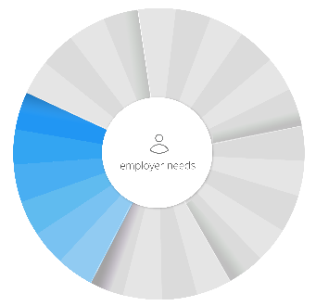
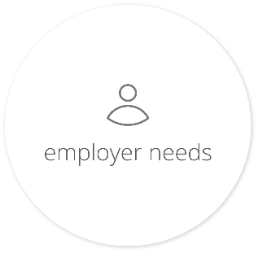
From compliance to communication, let us provide a full spectrum of solutions for you and your company. We understand the challenges today’s employers face, and we know you’re asked to take on more than ever before. Expect more from a broker—expect our full spectrum of solutions.
Compliance
& Legislation
Online Enrollment
& HR Support
Insurance
Guidance
Communication
& Marketing
Claims
Analytics

From Brokers
Break away from the mold of the traditional broker. The average broker meets your basic needs when it comes to claims, plans and renewal negotiation. What about open enrollment? New legislation? Department of Labor (DOL) compliance?

From Technology Companies
New tech giants can be focused on curing the pains of HR, such as benefits administration and small compliance issues, but lack the personal touch and insurance expertise that an independent broker like us provides.
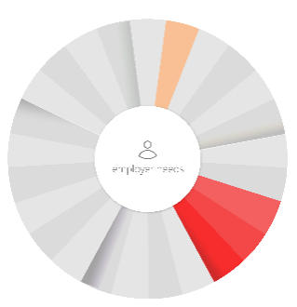

Typical
Services

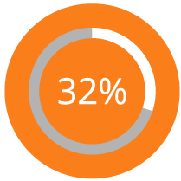 | 32 percent of business plans audited by the DOL received fines of over $10,000.
 | No need to worry—you can rest easy with our regular compliance newsletters, articles, action plans and support to keep you up to date and in the know.

89 percent of employees expect decision-making tools during open enrollment. | 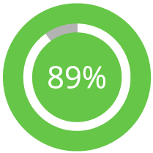
Our decision support tools match your industry, region and company size from a plan design perspective. We’ll provide medical and prescription analytics, employee retention plans and open enrollment assistance specified to your business needs and goals.

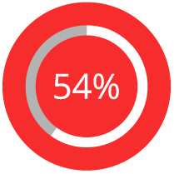 | 54 percent of employees say selecting a health plan is more complicated than solving a Rubik’s Cube.
 | Take the guesswork out of plan selection and simplify your day-to-day operations with our streamlined online enrollment, vacation tracking and more on a customized intranet site.

Only 34 percent of employees were aware of wellness plans offered by their employer. An inactive employee can cost you up to $1,500 extra in health costs per year.
Communication is the most important part of any relationship. Let us help you engage and educate your employees by providing health and wellness plans, benefits guides, and numerous safety and awareness materials.

We’re your trusted source.
Get all these services, plus the guidance to navigate the complexities of insurance, from a partner you can trust.

